**DBMS Laboratory**

**UE19CS304**

**5th Semester, Academic Year 2021-22**

Week #: 3 - ER Diagrams, Relational Schema and Create Statements. Date: 19/9/2021

|  |  |  |
| --- | --- | --- |
| Name :  SUMUKH RAJU BHAT | SRN :  PES1UG19CS519 | Section :  H |

1. ER Diagram for Zoo MiniWorld

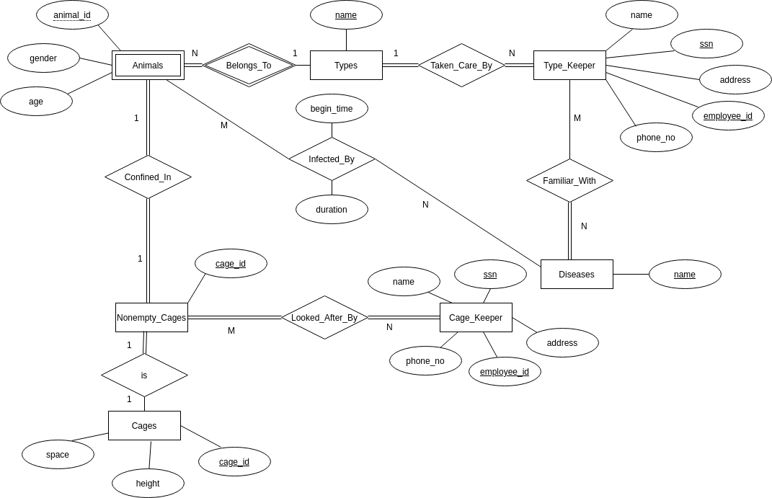

Some of the assumptions made:

- Instead of normalizing Cage_keeper and Type_Keeper as one entity with one attribute set, they are designed as different entities.

- It is assumed that 1 TypeKeeper can be familiar with many diseases and 1 disease is known to many TypeKeepers.

- It is also assumed that for every Cage_keeper there is a cage assigned.

- It is also assumed that every type can have multiple animals, but every animal belongs to only one type.

- Animal is a week entity w.r.t. types.

1. Relation Schema converted from ER Diagram of Zoo miniworld

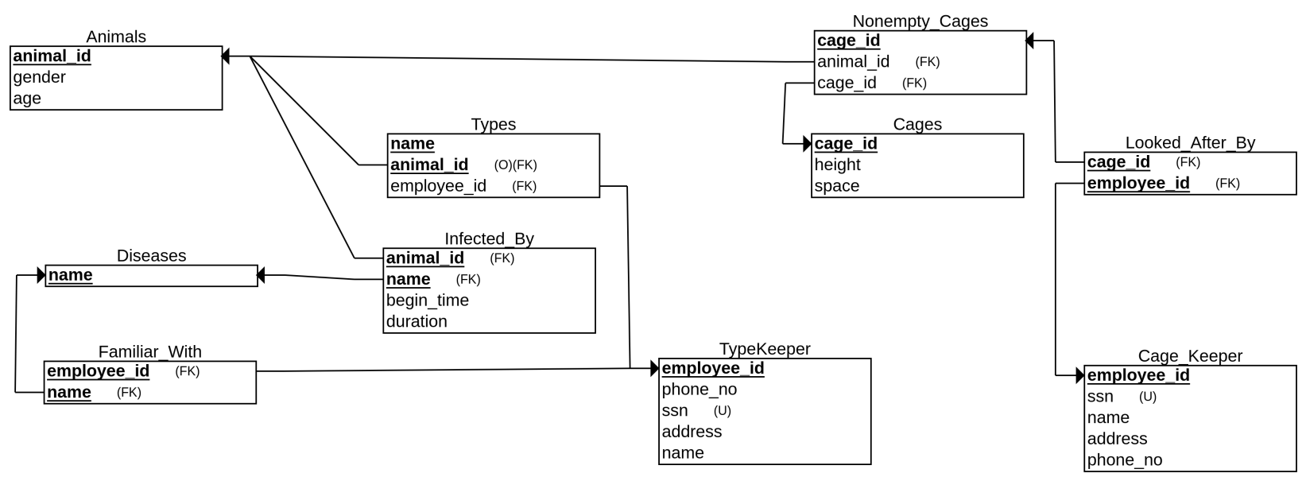

1. Create Statements

- Create Database named cs519

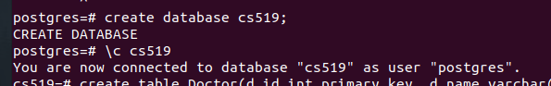

- Create given tables

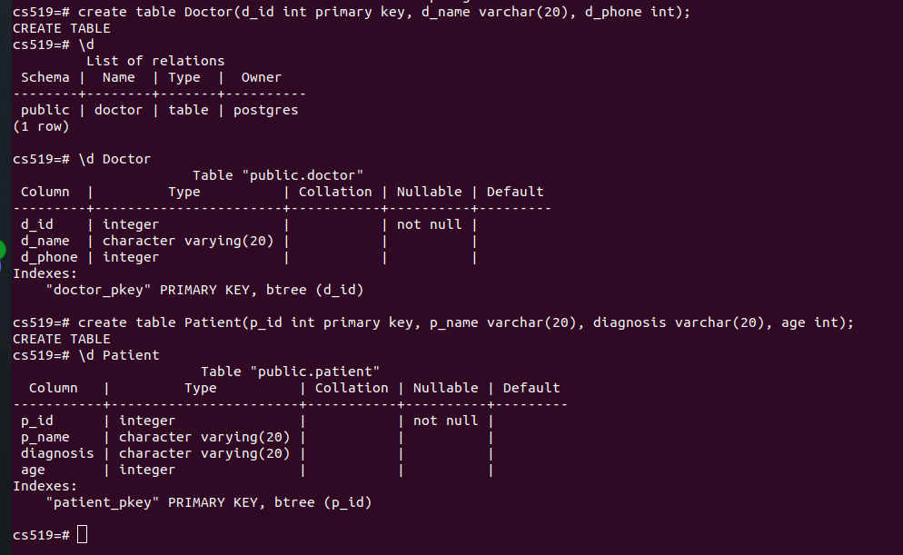

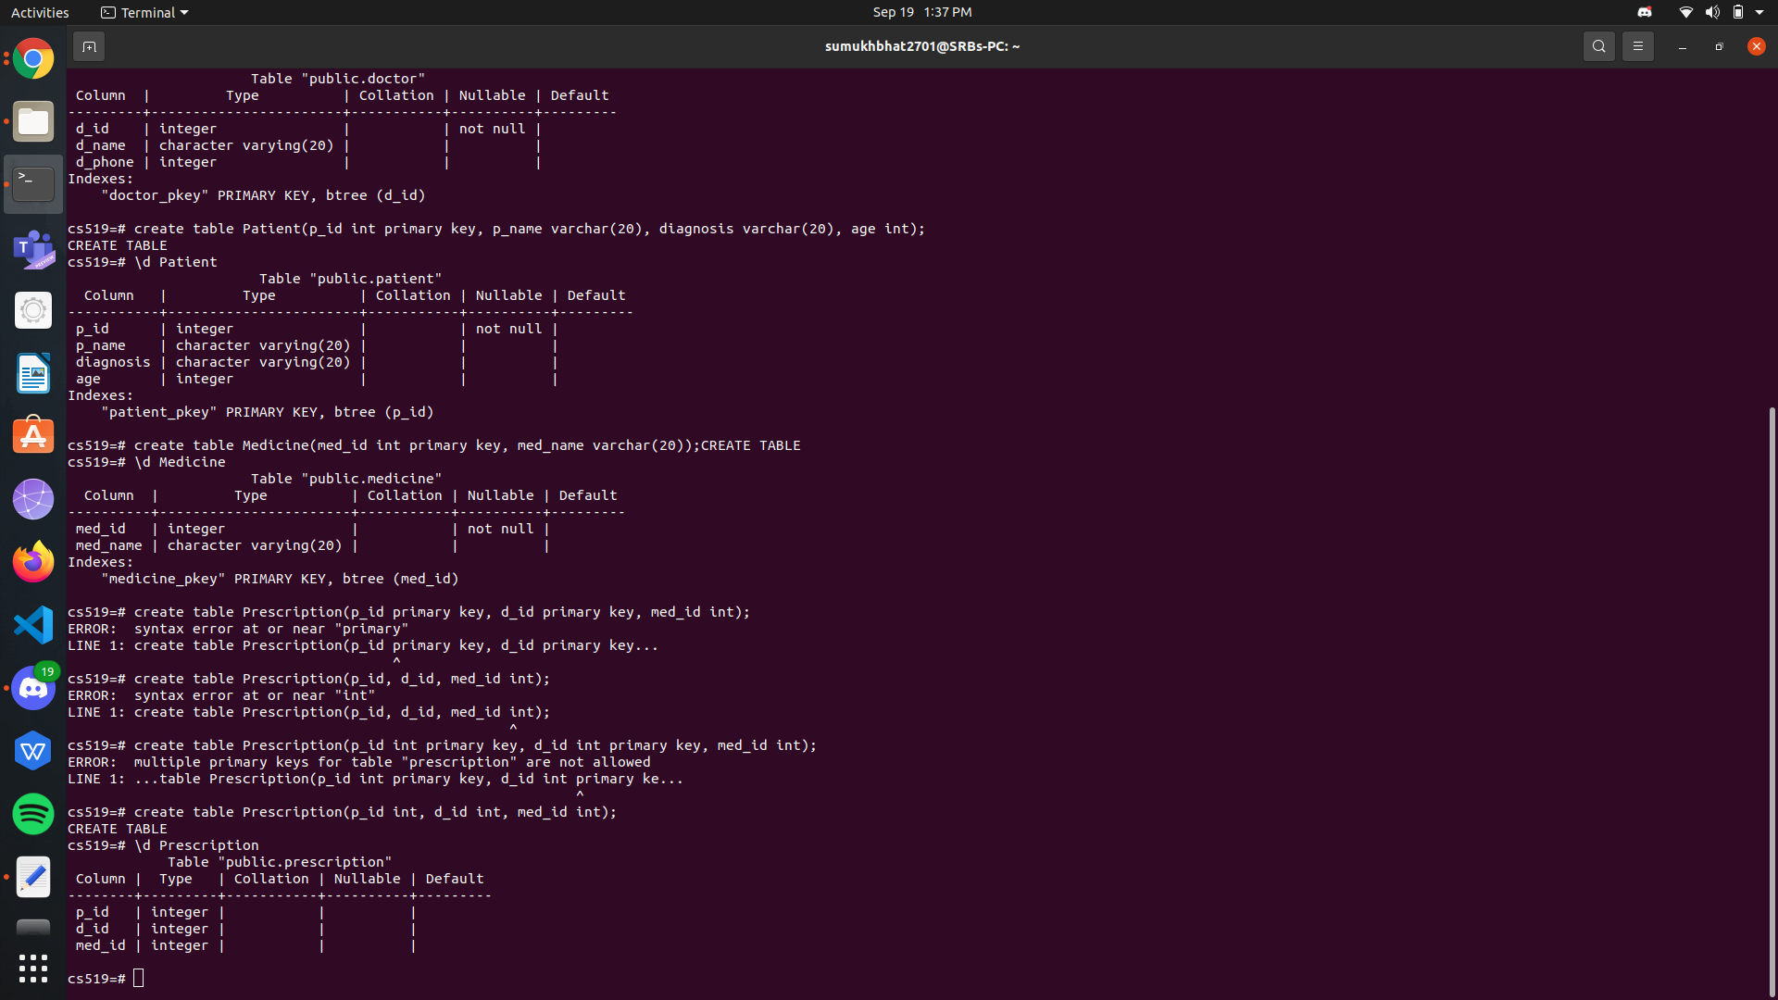

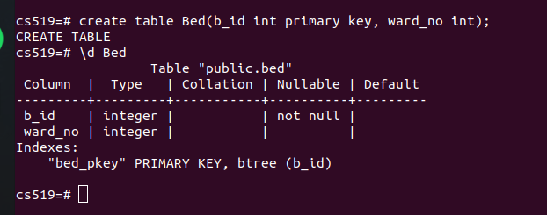

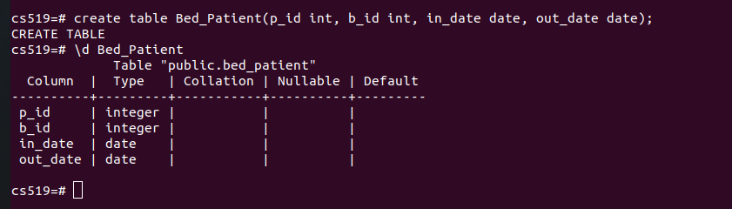

- Alter the constraints to set the primary keys of tables

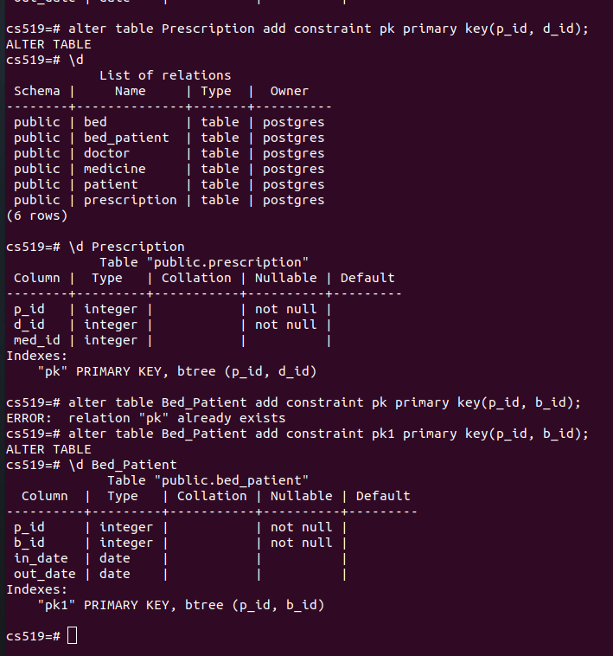

- Alter constraints to set foreign keys of tables

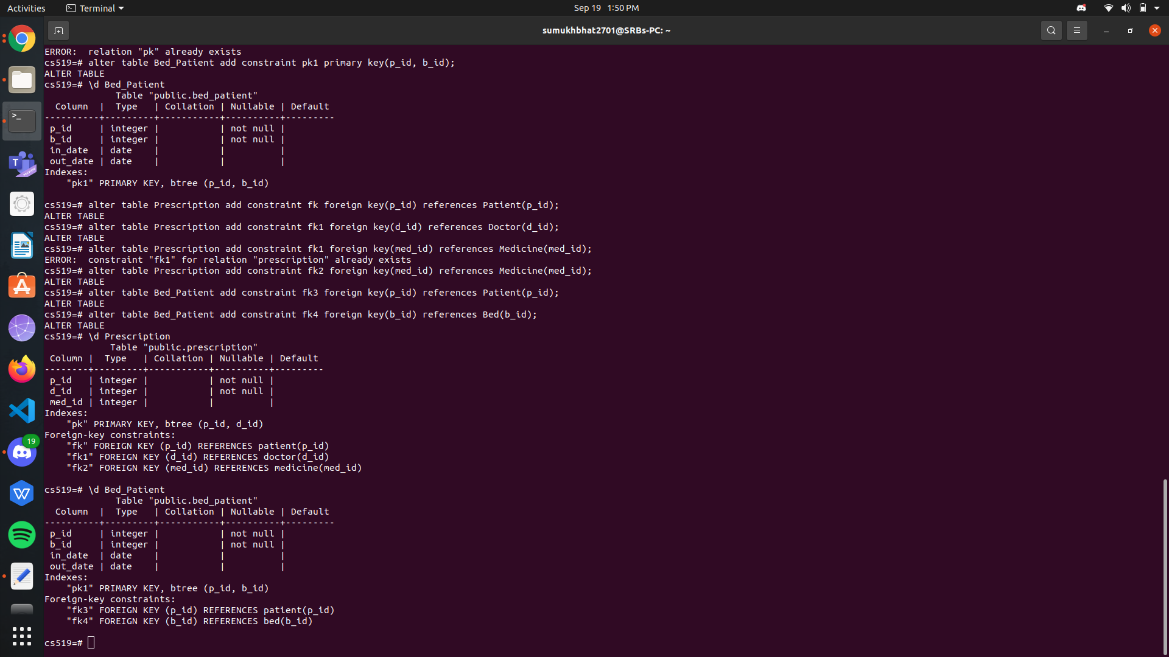

- Schemas after setting up tables

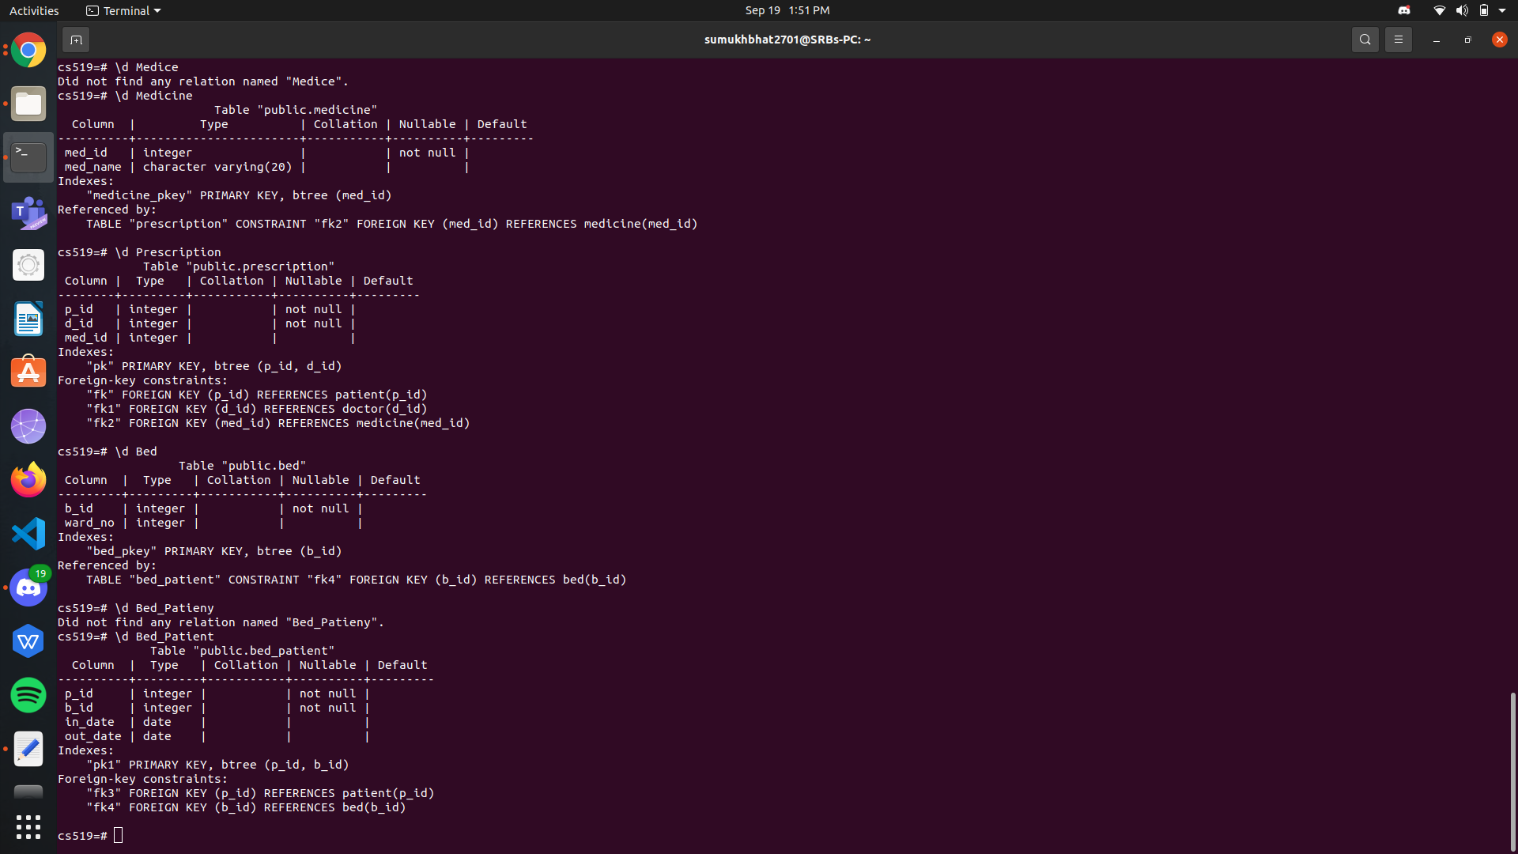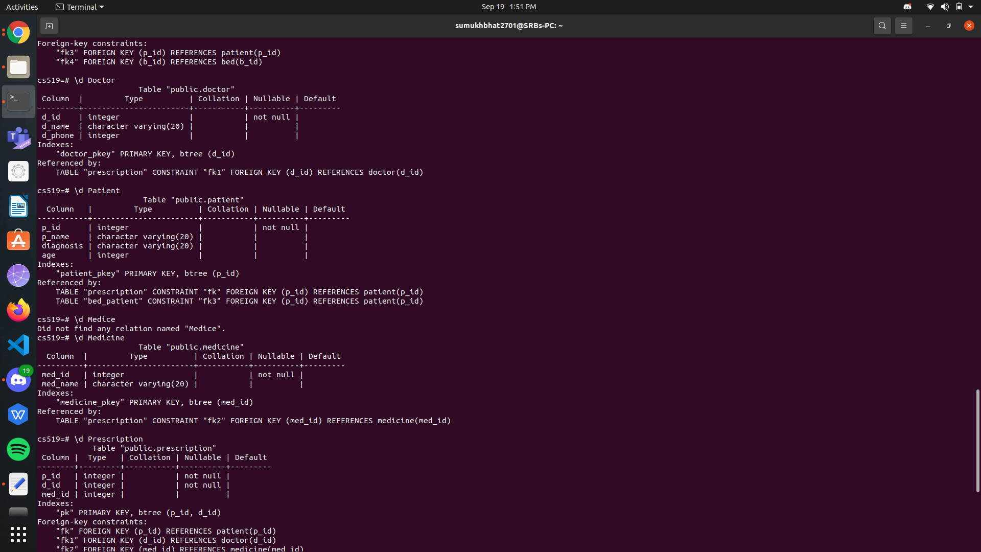

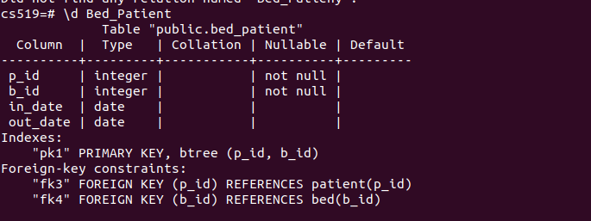

- Inserting 5 entries to each table

